# [***Law & Order: Organized Crime's Stabler Drunkenly Admits That He's in Love — 'EO' Hive, Assemble (and Watch!)***](https://tvline.com/2022/11/18/law-and-order-svu-stabler-loves-benson-drunk-video/)

By [Kimberly Roots](https://tvline.com/author/kimberly-roots/) / November 18 2022, 8:31 AM PST

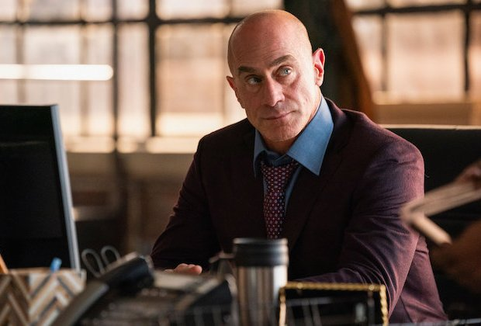

Courtesy of NBC

* [**3**](https://tvline.com/2022/11/18/law-and-order-svu-stabler-loves-benson-drunk-video/#comments)

Are we inching ever closer to [that parallel universe](https://tvline.com/2021/09/30/law-and-order-organized-crime-recap-season-2-episode-2-3-stabler-benson-letter/), or what?

Near the start of this week’s [*Law & Order: Organized Crime*](https://tvline.com/tag/law-and-order-organized-crime/), Elliot Stabler greeted his Italian partner Tia as she ambled out of his bedroom the morning after the events of the previous episode. As the friends/co-workers discussed her hangover and the amount of grappa they’d imbibed the previous evening, we learned two important pieces of information: 1) Despite his attraction to Tia and vice-versa, Elliot slept on the couch; and 2) their drunken conversation yielded a truth that even Elliot didn’t remember he’d admitted.

As Stabler joked about how Tia couldn’t recall what they’d talked about, she said, “I remember some things. The important parts. I guess, yeah, except her name.” The comment gave Stabler pause, and he asked to who she was referring. “You said there’s a woman you’re in love with,” she explained. Stabler suddenly got REALLY interested in the toast he was buttering, asking only, “I did?” Tia, knowing she’d touched on Something Big, responded, “Love shouldn’t be complicated. Love affairs, yes. They can get messy. But love, that’s different.”

Even if you’re not an ‘EO’ ‘shipper, Stabler has got to be talking about Capt. Olivia Benson, his former *Law & Order: SVU* partner… right?! (You can judge for yourself by [watching the video here](https://www.nbc.com/nbc-insider/law-order-organized-crime-did-stabler-just-admit-to-being-in-love-with-benson).)

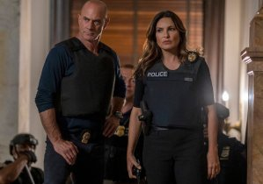

It’s not like there’s no precedent for this exact sentiment in the *Law & Order*verse. In *Organized Crime*‘s first season, [El blurted out that he loved Liv](https://tvline.com/2021/04/22/law-and-order-svu-stabler-benson-i-love-you-recap-organized-crime-intervention-season-1-episode-4/) — to her face — during a highly emotional intervention following the murder of his wife, Kathy. But he was out of sorts at the time, and though the sentiment clearly surprised both of them, it was pushed aside as the hunt for Kathy’s killer intensified.

[**The *Law & Order: SVU* Pilot Revisited**](https://tvline.com/gallery/law-and-order-svu-pilot-photos-season-1-episode-1-mariska-hargitay/?ref=https://tvline.com/2022/11/18/law-and-order-svu-stabler-loves-benson-drunk-video/)

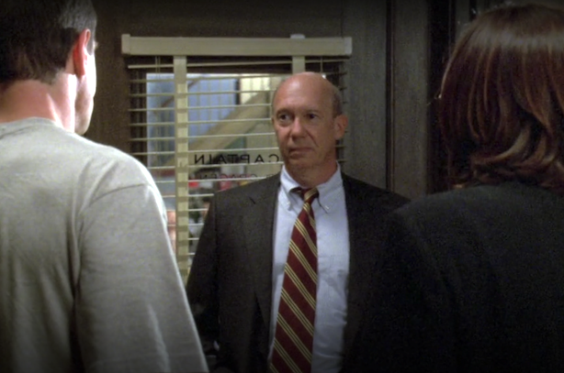

[**Launch Gallery**](https://tvline.com/gallery/law-and-order-svu-pilot-photos-season-1-episode-1-mariska-hargitay/?ref=https://tvline.com/2022/11/18/law-and-order-svu-stabler-loves-benson-drunk-video/)

Then, in *OC*‘s Season 2, Stabler wound up at Benson’s place after he’d been dosed with a powerful drug during an undercover operation. As he rambled semi-coherently, [he admitted that Kathy — not he — had written the letter](https://tvline.com/2021/09/30/law-and-order-organized-crime-recap-season-2-episode-2-3-stabler-benson-letter/) he’d handed Liv in Season 1. During that conversation, we found out that the missive had been all about how “what we were to each other was never real, and that we got in the way of each other being who and where we needed to be,” which obviously had felt, to Benson, like her old partner was trying to put some emotional distance in their admittedly turbulent friendship.

But there was a bit at the end about how, in a parallel universe, “‘It will always be you and I,'” drugged Elliot recited, adding: “I wrote that. I slipped it in there before sealing the envelope.” (For what it’s worth, [here’s what *we* thought the letter should’ve said](https://tvline.com/2021/09/29/law-and-order-svu-stabler-letter-organized-crime-season-2-photos/).)

**Both *SVU* and *OC* will return for their fall finales on Thursday, Dec. 8. Until then, hit the comments with your thoughts!**